 [Translated from German to English - www.onlinedoctranslator.com](https://www.onlinedoctranslator.com/en/?utm_source=onlinedoctranslator&utm_medium=docx&utm_campaign=attribution)

**1 Mechanics**

**Test unit technical documentation**

by Paul Christian! GmbH & Co. KG 1

**1.1 Functional description**

**The inspection unit functional assembly consists of four inspection stations where workpieces and their material properties and contours are inspected. An optical, a capacitive, and an inductive sensor are used to inspect the material properties. A double-acting pneumatic cylinder acts as a mechanical probe to check the workpiece contour.**

**The functional module is completely built on a mounting platform measuring 80 x 145 mm and can be flexibly mounted individually or together with other functional modules on an aluminum profile plate.**

**Two 8-bit transfer connectors are available as transfer modules for connection to three digital PLC inputs and two digital PLC outputs.**

**The supply voltage of the functional module is 24 VDC and is provided via the 10-pin connecting cable.**

**The air supply is via a 4 mm air connection (plug-in coupling), the operating pressure is 4 bar.**

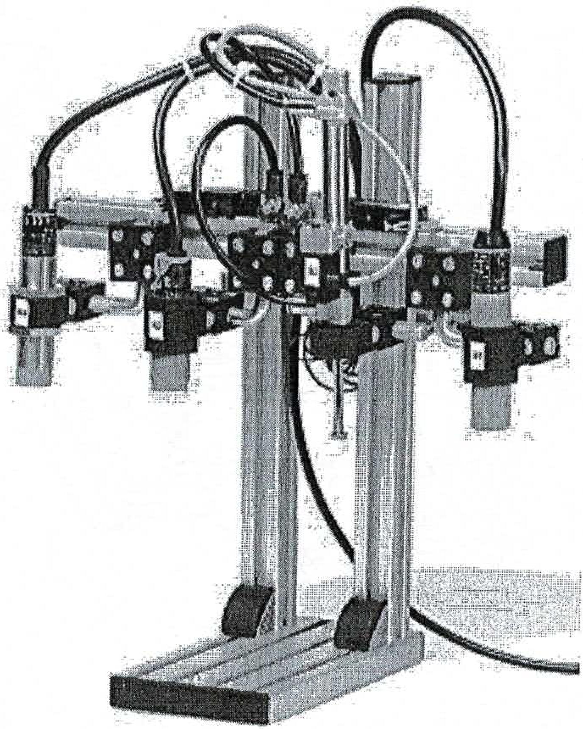

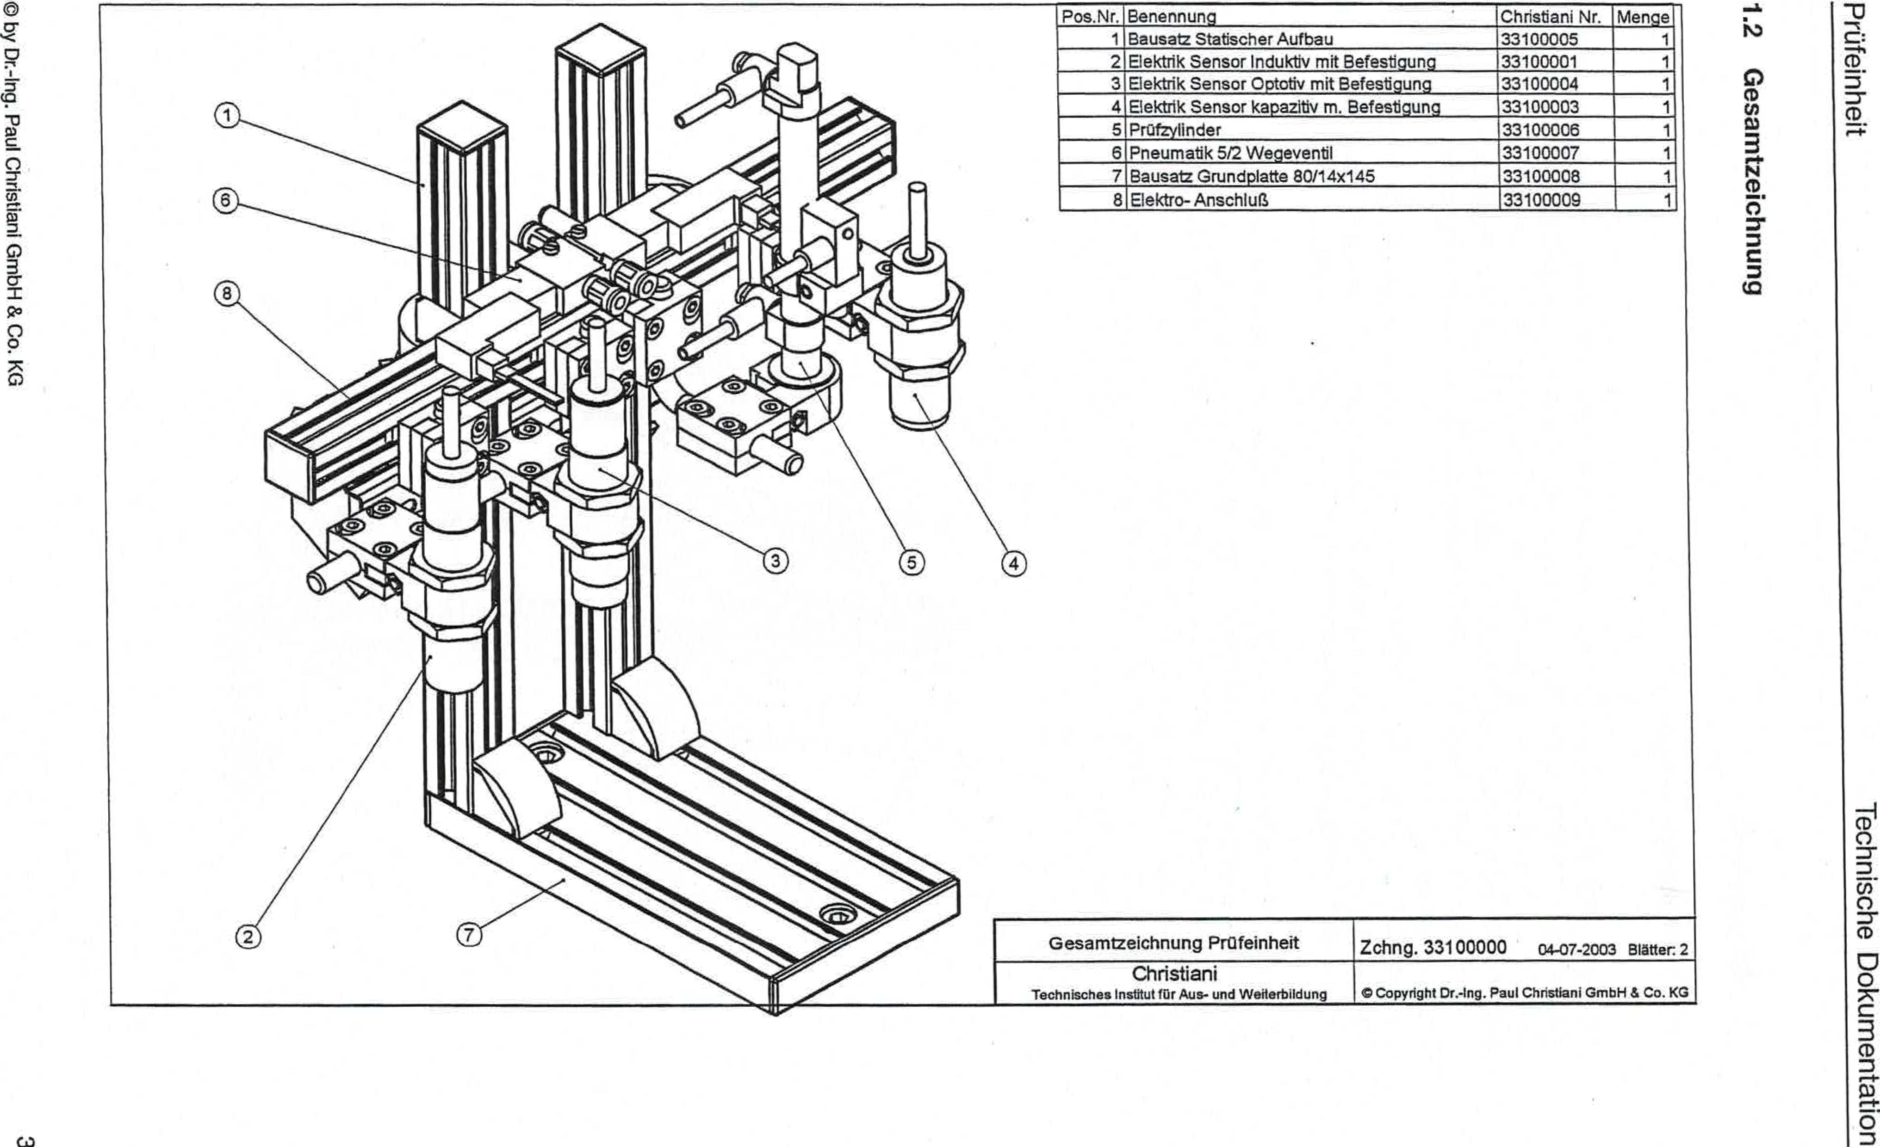

0}1 •03 2 Hqw0 penspLi3 ined '6W-ua Eq 0

**6unuqopziwesao**

2:
  
CO

(i)

r=,

uopluewmpo etpspLioal

|  |  |  |  |
| --- | --- | --- | --- |
| Item No. | designation | Christian No.  33100005 | Crowd  1 |
| 1 | Static construction kit |
| 2 | Electric sensor inductive with mounting | 33100001 | 1 |
| 3 | Electrical sensor optotive with mounting 133100004 |  | 1 |
| 4 | Electrical sensor capacitive with mounting | 33100003 | 1 |
| 5 | Test cylinder | 33100006 | 1 |
| 6 | Pneumatic 5/2 way valve | 33100007 | 1 |
| 7 | Base plate kit 80/14x145 | 33100008 | 1 |
| 8 | Electrical connection | 33100009 |  |

rOverall drawing of the test unit

Christiani

TechnicalInstitute for Training and Continuing Education

Drawing 33100000 04-07-2003 Pages 2

Copyright Dr.-Ing. Paul ChnstianiGmbH & Co. KG